銘傳大學海外移地教學與菁英海外留學計畫
獎助學金申請核發說明
Ming Chuan University Announcement for Awarding Scholarships for Study Abroad Program

項目  Subject | 111學年(下學期)赴海外交換者  Students participating in 2023 Spring Semester Study Abroad Program
申請資格  Qualification | - 申請資格請見下頁作業辦法說明  - 舉例說明：大學部學生出國之前一學期學業成績，如111下學期出國，即111上學期學業成績平均70分以上，且操行成績84分以上者得申請獎勵金  - 此獎勵金不受理​陸生申請  - 此獎勵金不受理學海飛颺、學海惜珠獲獎生  - Details see next pages.  - Average academic grade of the previous semester (i.e. Fall 2022) over 70, conduct grade over 84.
第一階段  繳交書面文件  Stage 1:  Submit Paper Document | - 申請者本人在下頁”收據Receipt”反黑的欄位處填妥領款人姓名、身分證字號、戶籍地址、學號等資料後，在”領款人蓋(簽)章(Sign)”親筆簽名、蓋章。”收據Receipt”請在2023年1月6日(五)之前繳交至國教處辦公室See “Receipt”. Fill in name, ID/ARC Number, Address, Student Number, and then print out and sign your name in person. Submit “Receipt” to IEE office before January 6th, 2023 (Friday).  文件亦可交付郵寄, 地址: 33348 台灣桃園市龜山區德明路5號銘傳大學 國教處 朱亭佳老師收  IEE office mailing address: No. 5, De-Ming Rd., Gui-Shan, Taoyuan 33348, Taiwan  Ms. Daphne Chu, International Education and Exchange Division, Ming Chuan University  - 銘傳學生証正反影本(請自行黏貼在”收據”背面)Clear Copy of MCU Student ID Card (please attach on the reverse side of the Receipt)  - 身份証正反影本(請自行黏貼在”收據”背面)Clear Copy of ID/ ARC Card (please attach on the reverse side of the Receipt)  - 外籍學生請提供護照影本For international students, a clear copy of your passport
第二階段  網路線上申請方式  Stage 2:  Online Application | 網路線上申請  參考下頁“線上申請系統”公告說明，請在2023年3月1日~3月15日完成線上申請  Scholarship Online Application   Apply On-line from March 1st ~ March 15th, 2023. Details see next pages.
預計審核日期  Committee Review Tentative Schedule | 111學年度下學期開學後，召開獎學金審核委員會，預計2023年4月底  Committee Review will take place in end April 2023.
獎學金預計  核發日期  Awarding Date  Tentative Schedule | 2023年6月底End of June 2023  如有異動，以最新公告為主 Subject to change.
獎學金核發方式  Awarding Procedure | 銀行撥款入戶  1. 請確實進入學生資訊系統填入學生本人金融機構帳戶資料，以台北富邦銀行帳戶或郵局帳戶為佳。  2. 無法提供上述金融機構帳戶者，請填寫其它行庫資料，如產生無法順利撥款者，將改支票方式領取(需親自赴校領取)。  Through Bank Remittance  - In MCU Student System, please make sure you fill in your personal bank account information in Taiwan, for example, the Taipei Fubon Bank or Postal Office.  - If student designates a bank account besides of the above two preferences and the remittance does not go successfully, the scholarship will be awarded via bank check and the recipient shall collect it in person at the university.
獎學金金額  Scholarship Award | 獎勵金金額以參與海外移地教學或菁英海外留學計畫地區為準，說明如下：  1.亞洲地區以每名新臺幣壹萬元整為原則  2.非亞洲地區每名新台幣貳萬元整為原則  本獎學金需待教育部高教深耕計畫辦公室通知核定後，方進行審查作業。  The amount of scholarship awarded is subject to the region of study abroad program, as follows:  - Students, who study abroad in the Asian region, will receive NTD 10,000 per person.  - Students, who study abroad outside the Asian region, will receive NTD 20,000 per person.  The scholarship program shall be announced based on the official notification of the Ministry of Education and school authorities in charge.
銘傳大學海外移地教學與菁英海外留學計畫獎勵金作業辦法

第一條 ＜主旨＞
為獎勵優秀學生順利完成學業並協助學生拓展國際視野，鼓勵勤學向上精神，特設立本辦法。
第二條 ＜申請資格＞
一、本校具正式學籍之學生(含外國籍正式學位生)，參與海外移地教學或菁英海外留學計畫，並符合下列條件之ㄧ者，得申請獎勵金：
1. 大學生之前一學期學業成績平均七十分以上，且操行成績八十四分以上者。
2. 研究生學業成績平均八十分以上，且操行成績八十四分以上者。
二、已獲得政府單位之獎學金或其他校外單位之全額獎學金者，不得申請之。
第三條 ＜獎勵金之金額＞
獎勵金金額以參與海外移地教學或菁英海外留學計畫地區為準，說明如下：
一、亞洲地區以每名新臺幣壹萬元整為原則；
二、非亞洲地區每名新台幣貳萬元整為原則；
為鼓勵清寒優秀學生出國研修，持有效之低收入戶證明或中低收入補助證明(須為各縣市政府行政主管機關開立)之清寒優秀學生，且在學學業成績優異者（以每班前三名為原則），基於獎優原則，獎勵額度為出國研修補助上限金額之二倍。
國際教育委員會得視經費狀況，酌予調整。
第四條 ＜申請辦法＞
一、申請人需於申請期限內至學生資訊系統進行線上申請獎勵金作業。
二、獎勵金申請人應備妥領據向國際教育交流處提出申請。
三、凡未於公告之規定期限內申請、所備文件未全或資格不符者，不予受理。
四、申請人所繳交之申請表件，不論核准與否，概不發還。
第五條 ＜審核程序＞
獎勵名單之決定，由國際教育委員會核定之。
第六條
本辦法經行政會議通過，校長核定後實施，修正時亦同。

(English version)
Ming Chuan University Procedures for Awarding Scholarships for Study Abroad Program

Article I ＜Purpose＞
This scholarship program is promulgated for the purpose of encouraging students to complete the study and broaden the horizon while studying abroad.

Article II ＜Qualification＞
1. Application qualifications:
MCU Students (including foreign students) who participate in the study abroad program and fulfill the qualifications as follows:
a. Undergraduate students – average academic grade of the previous semester over 70, conduct grade over 84
b. Graduate students – average academic grade over 80, conduct grade over 84
2. Students who already have MOFA, MOE, NSC, MOEA, and ICDF scholarship can not apply for this scholarship.

Article III ＜Scholarship Award＞
The amount of scholarship awarded is subject to the region of study abroad program, as follows:
- Students, who study abroad in the Asian region, will receive NTD 10,000 per person.
- Students, who study abroad outside the Asian region, will receive NTD 20,000 per person.
Students, who have ranked within the Top 3 in class for academic performances and who are having family financial difficulty with effective proof issued by municipal government agencies, will receive up to twice of the amount of the scholarship awarded as regulated in the previous paragraph.

Article IV ＜Application Documents＞
1. Applicant shall apply on-line within the given time period.
2. Submit the “Receipt” to the International Education and Exchange Division:
3. Failing to submit the required documents within the given time period, incomplete documents, or any violation of the regulations is not accepted.
4. Application documents will not be returned.

Article V ＜Committee Review＞
MCU International Committee reserves the right to decide on the final scholarship awardee list.

Article VI
Upon being passed at the Administrative Council and approved by the President, these regulations were announced and implemented. Any revision must follow the same procedure.
Study Abroad Scholarships
Apply On-Line Service!
To promote paperless campus and improve application process, Study Abroad Scholarships applicants, who need apply the scholarship, can apply on-line via MCU student information system, without the need to hand in request form.
Before traveling abroad, hand in the original receipt document, a clear photocopy of the front/back of ID/ARC card as well as your MCU Student ID card to the international and education division for the accounting procedure and complete the procedure. When you are overseas, please apply via the online system when the system is open in the beginning of the semester.

Online Application Period: March 1st ~ March 15th, 2023
Apply Steps:
- Enter “Student Information system.”
- Click on “Apply”
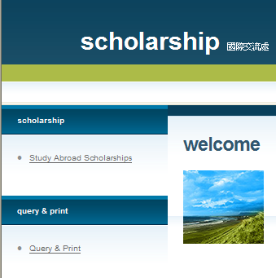
- Click on “International Scholarships”
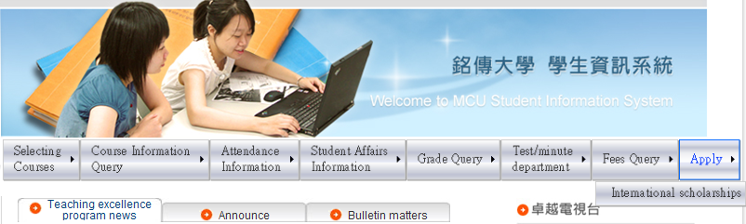
- Click on “Study Abroad Scholarships”

[海外移地教學與菁英海外留學計畫獎勵金] 線上申請系統
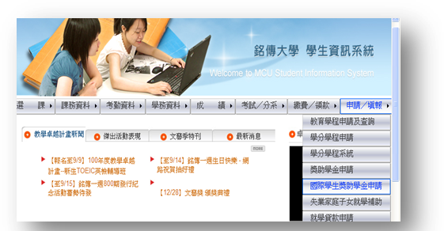
為推廣無紙化校園，並提高[海外移地教學與菁英海外留學計畫獎勵金]作業流暢，申請者可以經由學生資訊系統進行申請～為確保該獎學金為本人申請，出國前需繳交收據簽名正本、銘傳學生證及身分證正反面影本至國際教育交流處，學生於海外求學期間，需主動上網申請，才算是完成申請程序喲~
█ 線上申請期間: 2023/3/1~3/15
█ 申請步驟:
- 進入學生資訊系統
- 點選[申請/填報]
- 點選[國際學生獎助學金申請]
- 點選[海外移地教學與菁英海外
留學計畫獎勵金]

【個資宣告】此資料之蒐集僅限於會計與相關事務、憑證管理業務、協助公部門調查或執行業務及法令需求等目的使用，非經當事人同意，絕不轉做其他用途，亦不會公佈任何資訊，並遵循本校資料保存與安全控管規定辦理。
(詳細個資管理可參閱「銘傳大學個人資料保護管理要點」與「銘傳大學個人資料保護專區」http://pims.mcu.edu.tw)
銘 傳 大 學
收 據 Receipt
領款人姓名  (Name) |  |  |  |  |  |  |  |  |  |  |  |  |  | 所得種類  (Category of Income) |  |  |  |  |  | □薪資(50) □稿費、演講(9B)  █獎金(91) □薪資/獎金(50)  □
活動名稱(Activity Name) |  |  |  |  |  | 菁英海外留學計畫 |  |  |  |  |  |  |  | 案名(Program) |  |  |  |  |  | 111高教深耕計畫
用途(Used) |  |  |  |  |  | □鐘點費 □工讀費 □演講 □專任助理 █其他 獎金
工作期間(Working Dates) |  |  |  |  |  | 112年2月13日 至 112年6月16日 ， 共111下學期
計價標準  (Valuation Standard) |  |  |  |  |  | 單位數: 1 單價_____________元 共______________元
身分證字號/統一證號 (ID Number/Tax ID Number)
本國人  免填 | (International Student)出生年月日(Date of Birth) |  |  |  |  |  |  |  |  |  |  |  |  |  |  |  | 國籍(Nationality):
本國人  免填 |  |  |  |  |  |  |  |  |  |  |  |  |  |  |  |  | 護照號碼(Passport No.)：
戶籍地址  (Contact Address  In Taiwan) |  |  |  | 縣 區 鎮 村  鄰 路（街） 段 巷 弄 號  市 鄉 市 里 樓  Address in Taiwan:
應領金額(Total amount) |  |  |  |  | 新台幣 * 拾 萬 * 仟 * 佰 * 拾 * 元整﹒ NT$
代扣款(Withholding ) |  |  |  |  | 稅稅額(Tax)NT$ * 勞保NT$ * 健保NT$ * 退職金NT$ *  補充保費(NHI Supplementary Premiums)NT$ *
實領金額(Net Payment) |  |  |  |  | 新台幣 * 拾 萬 * 仟 * 佰 * 拾 * 元整﹒ NT$
領款人蓋(簽)章(Sign)
上列款項已向銘傳大學如數領訖 |  |  |  |  |  |  |  |  | 備註 |  | 學號(Student No.):____________  教職員編號(Staff & Faculty ID NO.):
註1.領款人請確認所得種類 (若不清楚，請洽財務處或至財務處網站) 及用途欄，並詳填身份証字號、戶籍地址及領款日期。
註2.此所得本校已登錄，並依限辦理申報，請務必填寫扣繳稅額$ 。
(扣稅標準，請查財務處→辦理各類所得扣繳應注意事項 )
註3.外籍人士請詳細填寫中英文姓名均應填寫（並請用正楷書寫）
註4.外籍人士(包含大陸人士)，請附護照及居留證影本。
註5.所得種類若為50薪資/獎金，將列入4倍投保金額累積，若有超過將代扣補充保費。

