The Netherlands Study Abroad Helpful Hints!

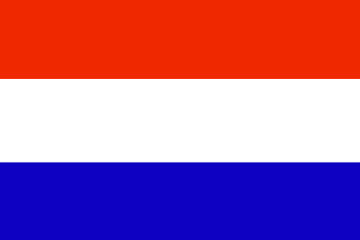
This information is to help you learn some basic information about the culture of The Netherlands. Good luck and enjoy your study abroad experience!

The Languages of The Netherlands:
- Dutch (Official Language: spoken by over 90% of population)
- Frisian (Official Language in the northern province: spoken by about 2% of population)
- Turkish and Arabic (Spoken by about .06% of population)

Behaviors of The Dutch
The people of the Dutch culture are usually disciplined, conservative and hardworking. They also believe in being practical and well organized individuals. Appearances to the Dutch are important and believe that cleanliness and neatness are important. It is important to recognize that the Dutch can be private people, so do not be offended if they do not share lots of information with you concerning their personal lives.

Meet and Greet
The Dutch use a firm handshake, followed by a smile to greet others. If people are close friends, they may “air kiss” each other on each check three times starting with the left cheek.

Gift Giving
If you are invited to a Dutch home, it is important to bring a gift which may include: chocolates, a potted plant, a book or flowers. Avoid bringing white lilies or chrysanthemums since these are usually associated with funerals. Also, avoid bringing wine as a gift.
Table Manners
The Dutch are reasonably formal when they dine together. Men must remain standing until all of the woman at the table take a seat. Also, it is common to eat all food with utensils, including sandwiches. It is important to finish all of the food on your plate. When you are finished with your meal, set your utensils parallel across the plate towards the right side. Enjoy your meal!

Weather
The weather of The Netherlands can vary greatly from -1 Celsius in the cooler months to 22 Celsius in the summer months. Please check the weather on the internet for the weather you will experience during your stay in The Netherlands!

Netherlands Newspapers
To read more about your study abroad location, check out current newspapers. The following website as well as others will provide you with information concerning your new home.
- Netherlands Post: www.netherslandspost.com
- Netherlands News: www.headlinespot.com

Other Sources of Information:
- Locate local newspapers: www.google.com
- Check the weather: www.weather.com

International Dialing Code
The International Dialing Code for The Netherlands is +31.

(Information adapted from: http://www.isep.org/students/Placed/handbook_staying_in_touch.asp?country=18 and http://www.kwintessential.co.uk/resources/country-profiles.html)

